Report On

**Underwater image noise cancellation**

Submitted in partial fulfillment of the requirements of the Mini project in

Semester V of Third Year Computer Engineering

by

Aman Sheikh (34)

Saurabh Shukla (39)

Onkar Suryavanshi (42)

Rahul Shah (65)

Mentor

Prof. Anil Hingmire



**University of Mumbai**

**Vidyavardhini's College of Engineering & Technology**

**Department of Computer Engineering**



**(A.Y. 2022-23)**

**Vidyavardhini's College of Engineering & Technology**

**Department of Computer Engineering**

**CERTIFICATE**

This is to certify that the Mini Project entitled **“ Underwater Image Noise Cancellation ”** is a bonafide work of **Aman Sheikh (34), Saurabh Shukla (39),** **Onkar Suryavanshi(42) and Rahul Shah (65)** submitted to the University of Mumbai in partial fulfillment of the requirement for the award of the degree of **“Bachelor of Engineering”** in Semester V of Third Year **“Computer Engineering” .**

|  |  |  |
| --- | --- | --- |
|  | ______________________  Prof. Anil Hingmire  Mentor |  |
| ___________________ |  | _______________ |
| Dr. Megha Trivedi  Head of Department |  | Dr. H.V. Vankudre  Principal |

**Vidyavardhini's College of Engineering & Technology**

**Department of Computer Engineering**

# Mini Project Approval

This Course Project entitled “**Underwater Image Noise Cancellation”**

by of **Aman Sheikh (34), Saurabh Shukla (39),** **Onkar Suryavanshi(42) and Rahul Shah (65)** is approved for the degree of **Bachelor of Engineering**  in Semester V of Third Year **Computer Engineering .**

Examiners

1………………………………………

(Internal Examiner Name & Sign)

2…………………………………….

(External Examiner Name & Sign)

Date:

Place:

**Abstract**

Under-water sensing and image processing play major roles in oceanic scientific studies. One of the related challenges is that the absorption and scattering of light in underwater settings degrades the quality of the imaging. The major drawbacks of underwater imaging are color distortion, low contrast, and loss of detail (especially edge information). **i**mage Enhancement is a process to make a input image more accurate by sharpening image features like Contrast. Under-water Images which are important source of interest for scientific research suffers poor visibility due to dust/noise present in the underwater. Our aim is to introduce an effective technique to enhance the images captured underwater and degraded due to the medium scattering and absorption of the water medium and providing a more Clearer image from a Noisy Image using machine learning and the out put images can be of great source of information for underwater excavations, marine life preservations etc.

**Acknowledgement**

We would like to express our special thanks of gratitude to our institute **Vidyavardhini’s College of Engineering and Technology**, Our Principle **Dr. H.V. Vankudre**, and our Head of the Department **Dr Megha Trivedi** and Our Subject teacher and Mentor **Prof. Anil Hingmire** who have gave this Opportunity to make this Course project on the topic Underwater Image Noise Cancellation. This has greatly helped us in Expanding Core Knowledge of all the subjects. Lastly, we would like to thank each other to complete this project in the allotted time frame.

# Contents

|  |  |  |  |
| --- | --- | --- | --- |
|  | **Abstract** | |  |
|  | **Acknowledgement** | |  |
| **1** | **Introduction** | |  |
|  | 1.1 | Introduction | **2** |
|  | 1.2 | Problem statement & objective | **2** |
|  | 1.3 | Scope | **3** |
|  | 1.4 | Project contribution | **3** |
|  |  |  |  |
| **2** | **Proposed system** | |  |
|  | 2.1 | Introduction | **4** |
|  | 2.2 | Architecture/framework/block diagram | **5** |
|  | 2.3 | Algorithm and process design | **6** |
|  | 2.4 | Details of hardware & Software | **7** |
|  | 2.5 | Experiment and Result for validation and verification | **8-12** |
|  | 2.6 | Conclusion and future work | **12** |
|  | 2.7 | References | **13** |
|  | 2.8 | Plagiarism Report | **14-15** |
|  | 2.9 | Source Code | **16-38** |

**1.Introduction**

**1.1 Introduction**

With the increase of human utilization of the ocean, underwater robot technology has been developed to a great extent, which can replace artificial underwater operations under complicated working conditions. The main environmental perception method of the underwater robot is to obtain image information through the underwater vision system, but due to the scattering and absorption effects of the water body, the image enhancement effect captured by the system is not ideal. Image enhancement is the technique for processing the input underwater image to result it in a proper and clearly visible image which can be used for the various research applications. This image enhancement technique is helpful for improving the information which is present in the image. This image alters the visuality of the mage which is useful for improving the image information for the observer. Image enhancement in the underwater images would be difficult task as it would eliminates the information which is present inside the image while the enhancement process is carried out. Image enhancement identify the feature of the image. Enhancement process is carried out by increasing the image features like edge, contrast to increase the photographs for the research and study. Qualitative objective approach is used for the enhancing process to show the impressive images. Image enhancement includes many operations such as contrast stretching, noise clipping process, pseudo-coloring, noise filtering technique. Active range of the features of image have been amplified by the various detected features. Various existing algorithm of the enhancement process shows the images have the poor quality because of the nature of the light. When the light is entering into the water ,the light get refracted and it was absorbed and scattered as the water is denser medium than air. This light drops occurs when the light entered into the water and got scattered into the different directions. Scattering from the light caused by the blurring effect of the light and the reduction of color contrast. These effects changes in water in underwater images are not only by the nature of the water but also by the organisms and other material which is present in the water. Light have the different intensity and different wavelength according to the blue, green, red colors present in the water.

**1.2 Problem statement & Objective**

1. Image Enhancement is a process to make a input image more accurate by sharpening image features like Contrast.
2. Underwater Images which are important source of interest for scientific research , suffers poor visibility due to dust/noise present underwater.
3. Our aim is to introduce an effective technique to enhance the images captured underwater and degraded due to the medium scattering and absorption of the water medium and providing a more Clearer image from a Noisy Image.

**1.3 Scope of project**

1. Under-water sensing and image processing play major roles in oceanic scientific studies.
2. Underwater image filteration is being adapted by marine scientists for on-site coral reefs monitoring For classification of Coral Reefs .
3. For Aqua Tourism to make the images Underwater more attractive.

**1.4 Project contribution**

Each individual has their own strength and weakness. While learning and implementing this project, group was well structured and everyone contributed their 100 percent to it. We assigned each other a portion of project to accomplish, pulled together everyone inputs and reviewed each others work and updated weekly. We all conducted the research for the selection and continuation of the project at our own side. We all have equally developed the code.

## Proposed System

## 2.1 Introduction

With the increase of human utilization of the ocean, underwater robot technology has been developed to a great extent, which can replace artificial underwater operations under complicated working conditions. The main environmental perception method of the underwater robot is to obtain image information through the underwater vision system, but due to the scattering and absorption effects of the water body, the image enhancement effect captured by the system is not ideal. Image enhancement is the technique for processing the input underwater image to result it in a proper and clearly visible image which can be used for the various research applications. This image enhancement technique is helpful for improving the information which is present in the image. This image alters the visuality of the mage which is useful for improving the image information for the observer. Image enhancement in the underwater images would be difficult task as it would eliminates the information which is present inside the image while the enhancement process is carried out. Image enhancement identify the feature of the image. Enhancement process is carried out by increasing the image features like edge, contrast to increase the photographs for the research and study. Qualitative objective approach is used for the enhancing process to show the impressive images. Image enhancement includes many operations such as contrast stretching, noise clipping process, pseudo-coloring, noise filtering technique. Active range of the features of image have been amplified by the various detected features. Various existing algorithm of the enhancement process shows the images have the poor quality because of the nature of the light. When the light is entering into the water ,the light get refracted and it was absorbed and scattered as the water is denser medium than air. This light drops occurs when the light entered into the water and got scattered into the different directions. Scattering from the light caused by the blurring effect of the light and the reduction of color contrast. These effects changes in water in underwater images are not only by the nature of the water but also by the organisms and other material which is present in the water. Light have the different intensity and different wavelength according to the blue, green, red colors present in the water.

**2.2 Architecture and framework**

**2.3 Algorithms or process Design**

**2.4 Details of hardware and software**

**Hardware requirements .:**

* Processor should be quad core
* Processor speed be 2.1 GHz. Base frequency.
* Storage 20 GB.
* RAM 8 GB.
* Window 10(Recommended)

**Software requirements .:**

1. Python interpreter of version 3.6 and below.
2. Jupyter Notebook as IDE.
3. Libraries :
4. Numpy
5. Pandas
6. Tensorflow
   1. **Experiment and Results for Validation and Verification**

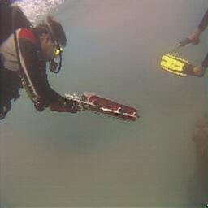

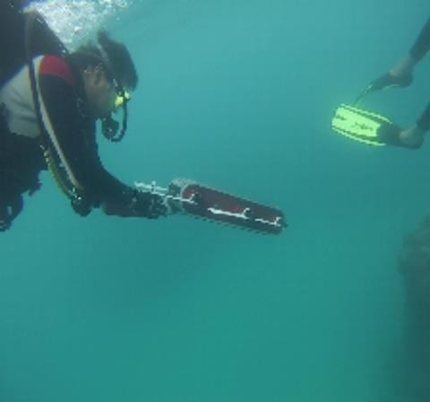

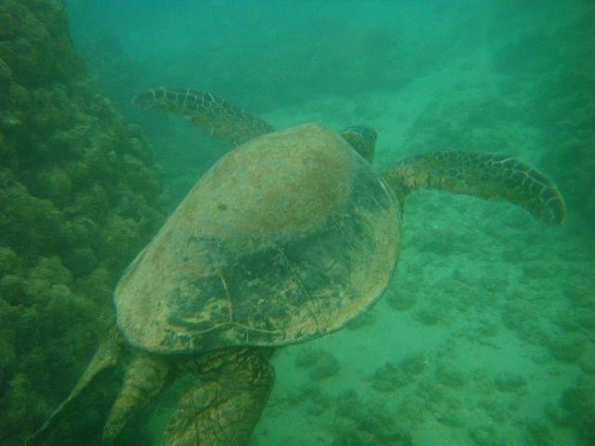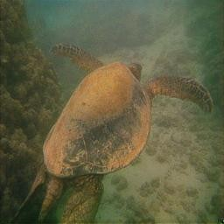

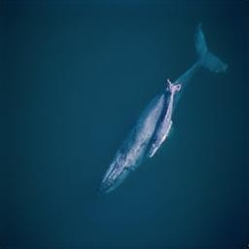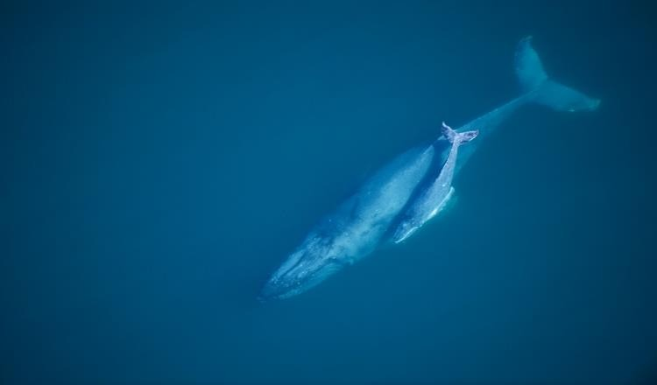

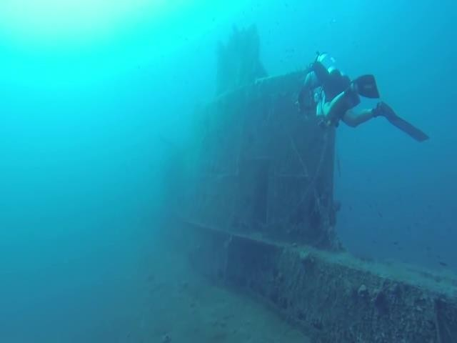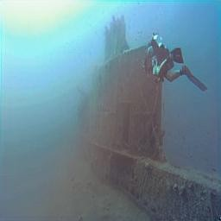

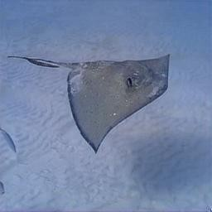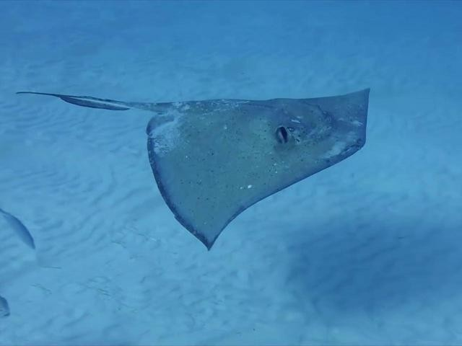

* 1. **Conclusion and Future work**

The algorithms proposed in this reports is a tool for increasing the quality of marine optical images. The proposed method enhances the image by reducing the noise using a bilateral trigonometric filter. Finally, the contrast of the image is improved using CLAHE. The noise in the image, due to back scattering, the presence of large particles, and haze, is addressed during the experiments, we found that the edges of the objects present in the image were not clear. Some of the images were detected with false edges and some details of the images were lost after applying the Gaussian filter. In addition, determining the parameters of CLAHE is a challenging task. This is one of the major disadvantages of applying CLAHE for improving image contrast. Thus, in the future, we would work on further improving the clarity of the image by concentrating on the image sharpness and the determination of parameters of CLAHE, thus increasing the resolution of the images further.

* 1. **References.:**
* Schettini, Raimondo, and Silvia Corchs. "Underwater image processing: state of the art of restoration and image enhancement methods." EURASIP Journal on Advances in Signal Processing 2010, no. 1 (2010): 746052
* He, Kaiming, Jian Sun, and Xiaoou Tang. "Single image haze removal using dark channel prior." IEEE transactions on pattern analysis and machine intelligence 33, no. 12 (2011): 2341- 2353.
* Kwok N M, Wang D, Jia X, et al. Gray world based color correction and intensity preservation for image enhancement[C]//2011 4th International Congress on Image and Signal Processing. IEEE, 2011, 2: 994-998.
* Li, Kangshun, Yunshan Wei, Zhen Yang, and Wenhua Wei. "Image inpainting algorithm based on TV model and evolutionary algorithm." Soft Computing 20, no. 3 (2016): 885-893.
* Wu, Zeling, and Haoxiang Wang. "Super-resolution reconstruction of SAR image based on non- local means denoising combined with BP neural network." arXiv preprint arXiv:1612.04755 (2016).
* Jiaying Xiong, Peixian Zhuang, and Yanan Zhang, "An Efficient Underwater Image Enhancement Model With Extensive Beer-Lambert Law", IEEE International Conference on Image Processing, 2020.
* [https://medium.com/@Packt_Pub/inside-the-generative-adversarial-networks-gan-architecture-](https://medium.com/%40Packt_Pub/inside-the-generative-adversarial-networks-gan-architecture-) 2435afbd6b3b